**UNEARTHING THE ENVIRONMENTAL IMPACT OF HUMAN ACTIVITY: A GLOBAL CO2 EMISSION ANALYSIS**

**1. Introduction :-**

**1.1 Introduction**

Carbon dioxide (CO2) is a colorless, odorless, non-flammable gas that naturally occurs in the atmosphere. CO2 is produced by body metabolism and is a normal component of exhaled breath. It also results from the burning of fossil fuels and natural sources such as volcanic eruptions. CO2 levels in outdoor air typically range from 300 to 400 ppm (0.03% to 0.04%) but can be as high as 600-900 ppm in metropolitan areas.

Carbon dioxide emissions are the primary driver of global climate change. It’s widely recognised that to avoid the worst impacts of climate change, the world needs to urgently reduce emissions. But, how this responsibility is shared between regions, countries, and individuals has been an endless point of contention in international discussions.

**1.2 Purpose**

This Project arises from the various ways in which Co2 emission in metric ton per capita of every country around the world. The data collected from 1975 to 2020. The emissions are compared as

* Total world annual emissions
* Total emissions by country
* Total CO2  emission over time
* CO2 emission India vs united states
* Total emissions by continent
* CO2  emission per capita

**2. Problems definition and design thinking**

**Empathy Map :-**

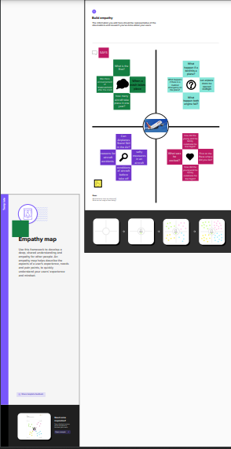

1. **Results :-**

**Tableau Output**

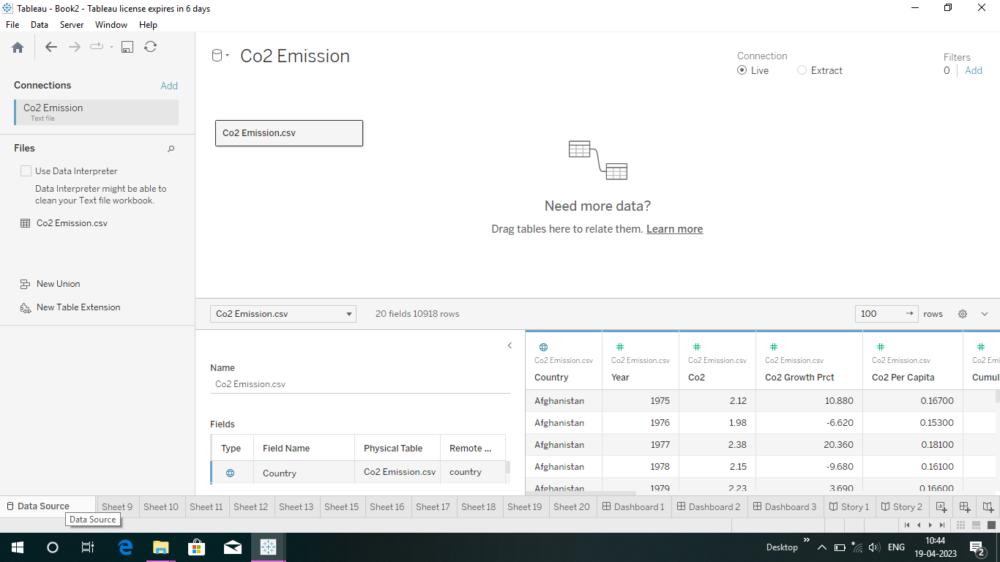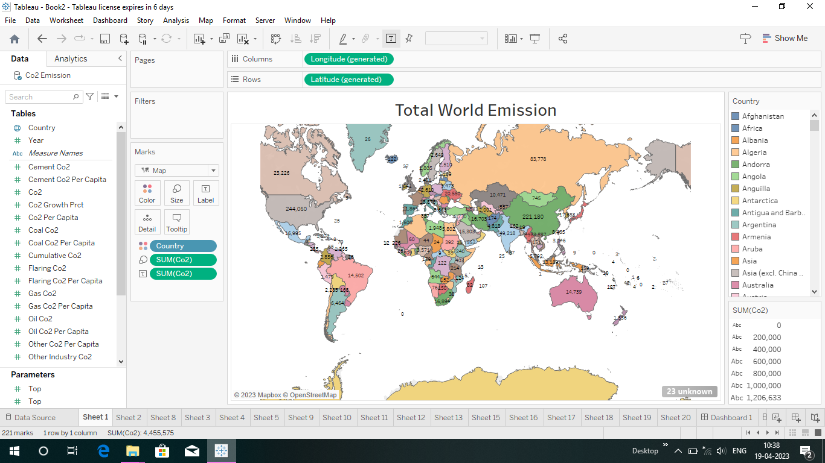

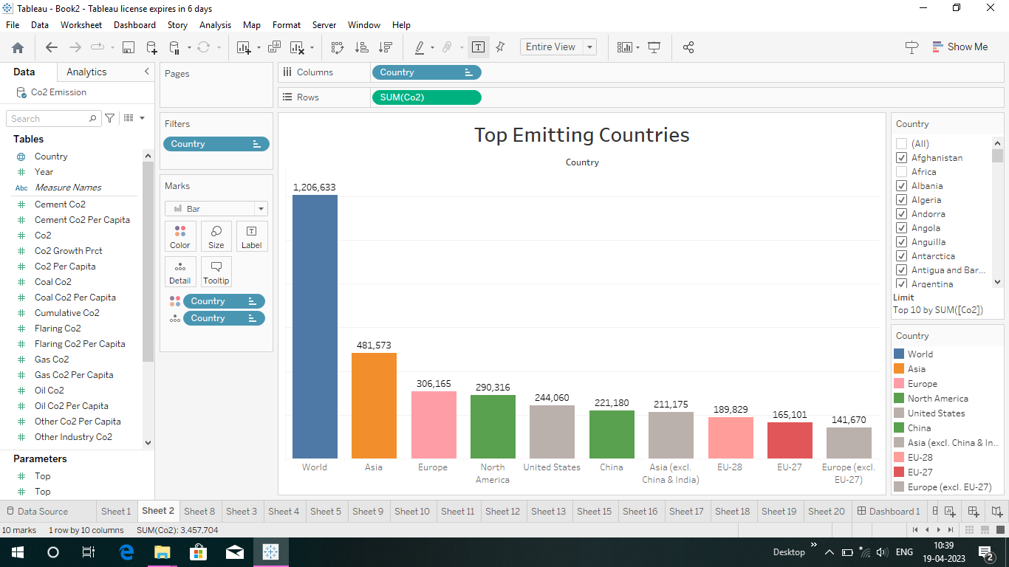

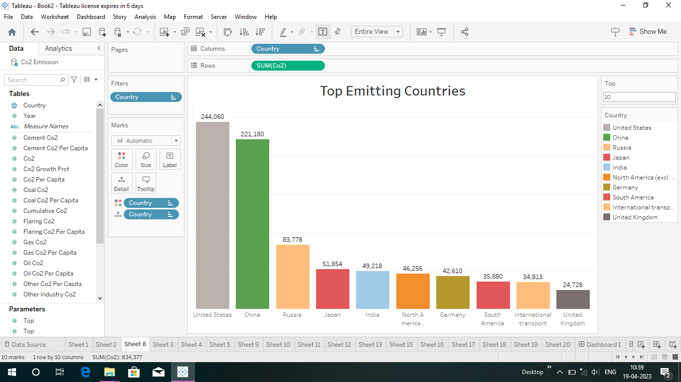

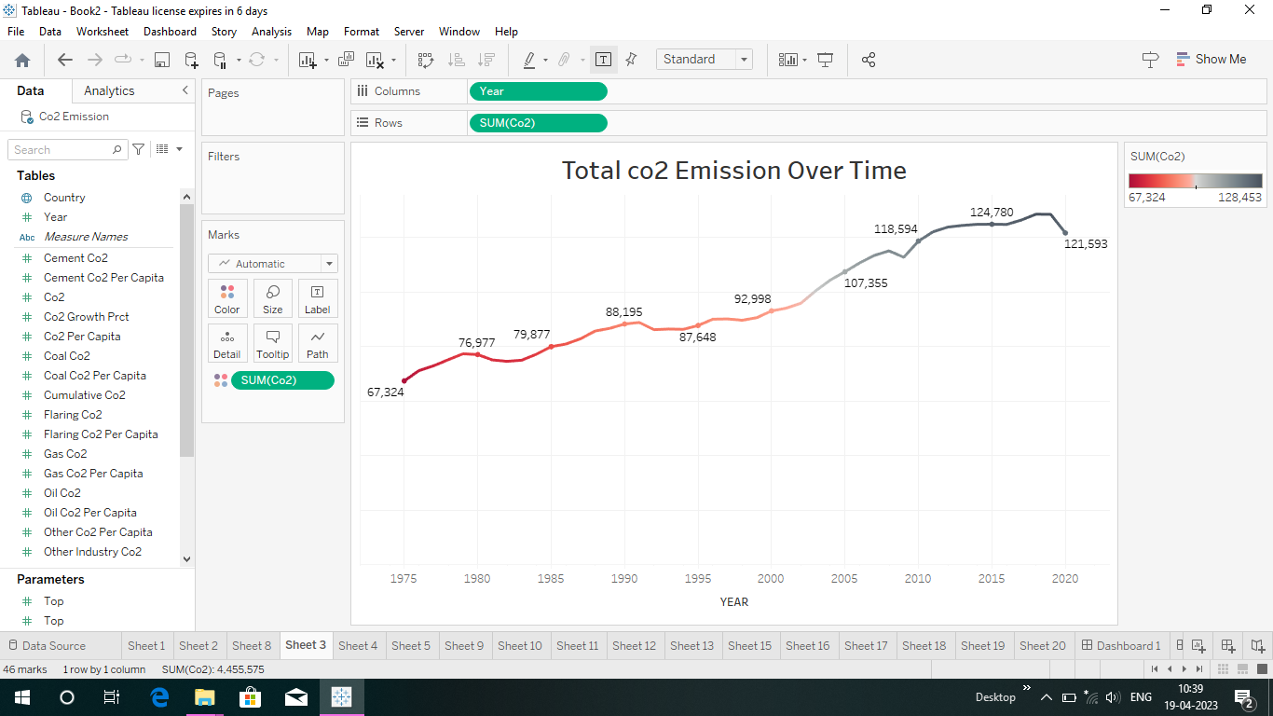

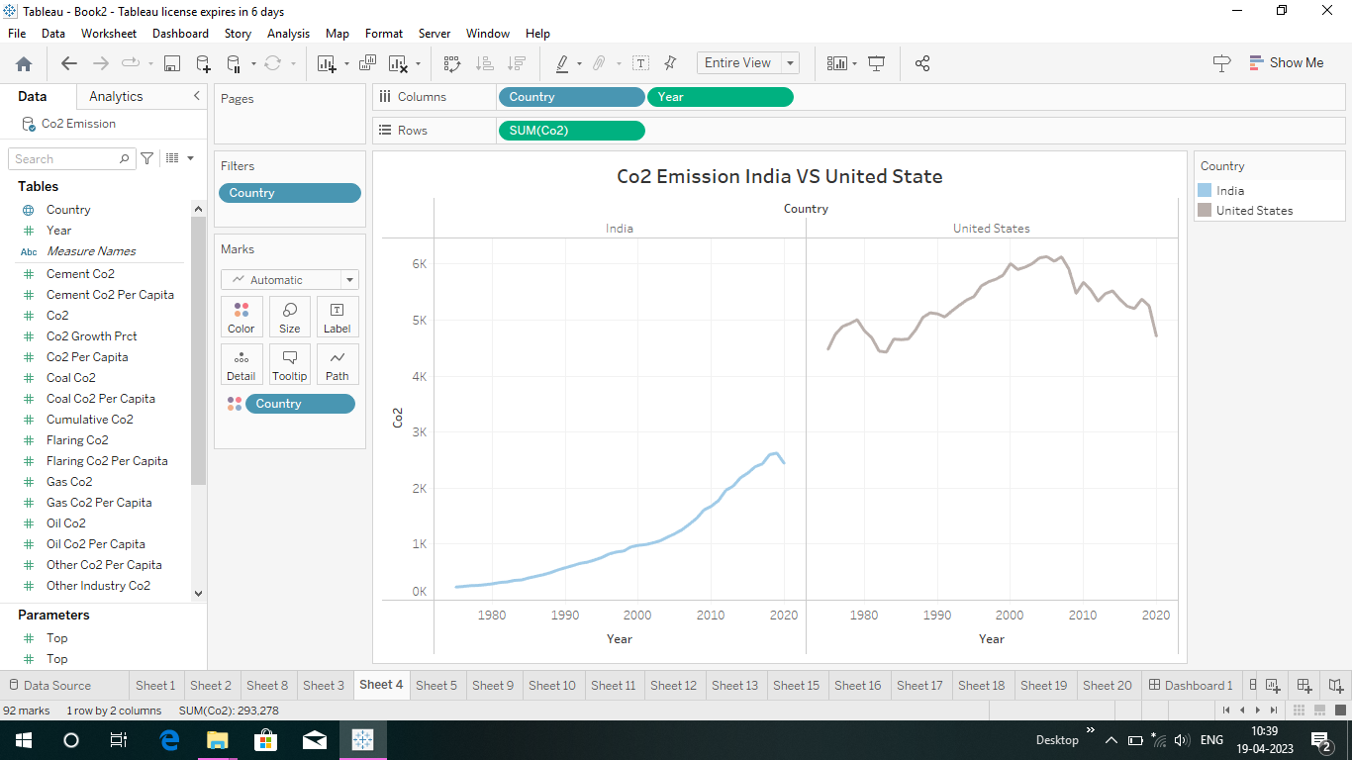

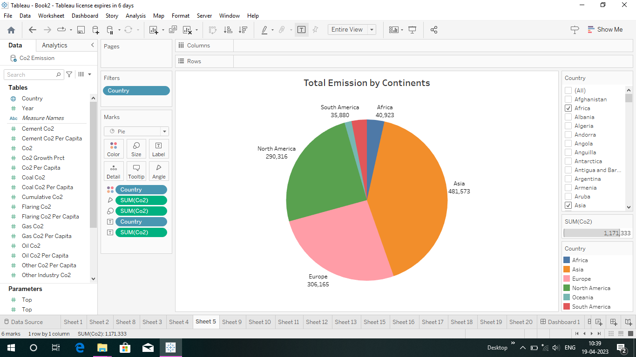

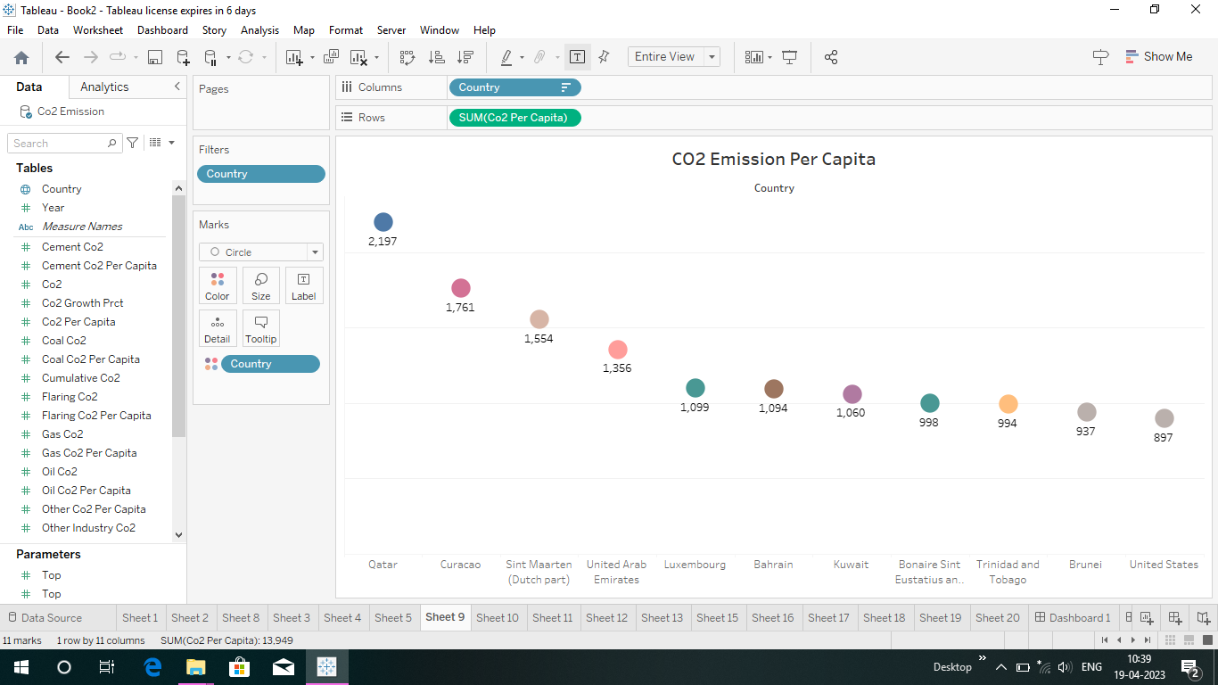

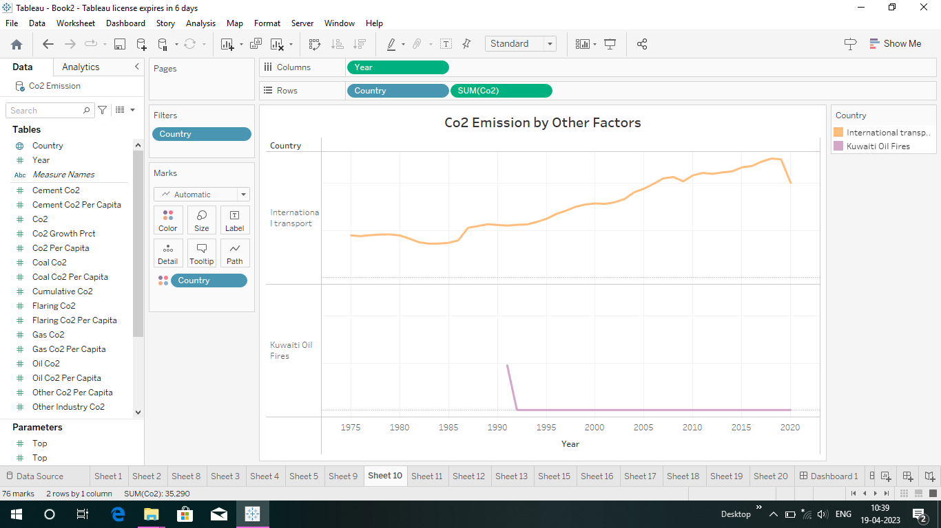

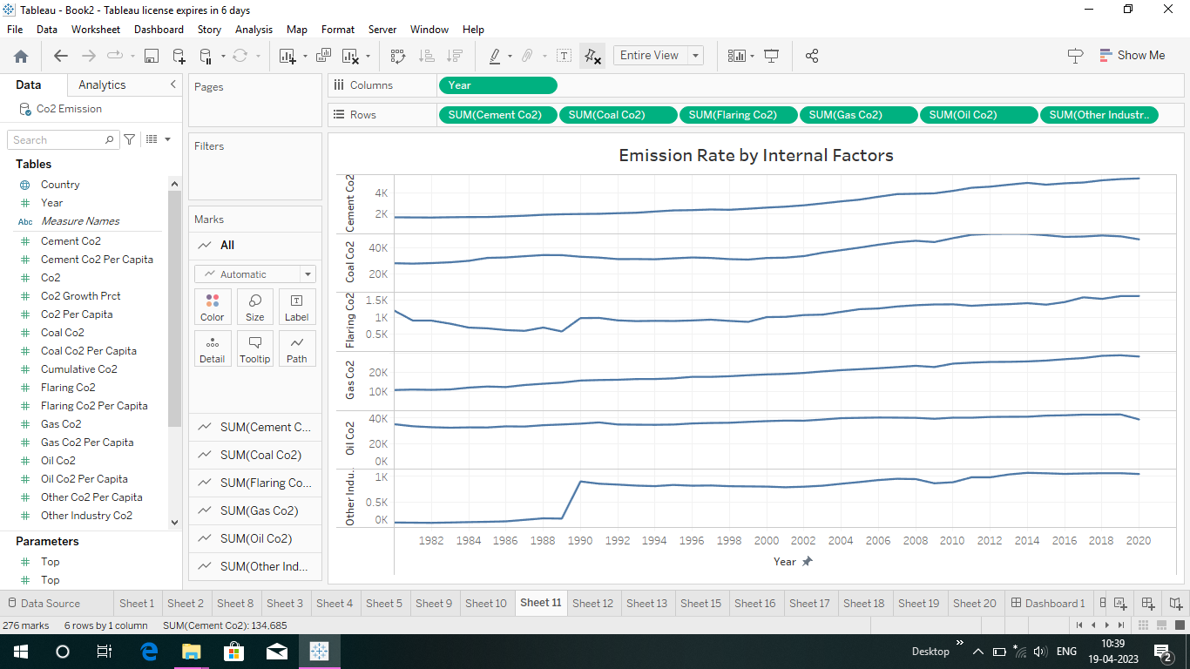

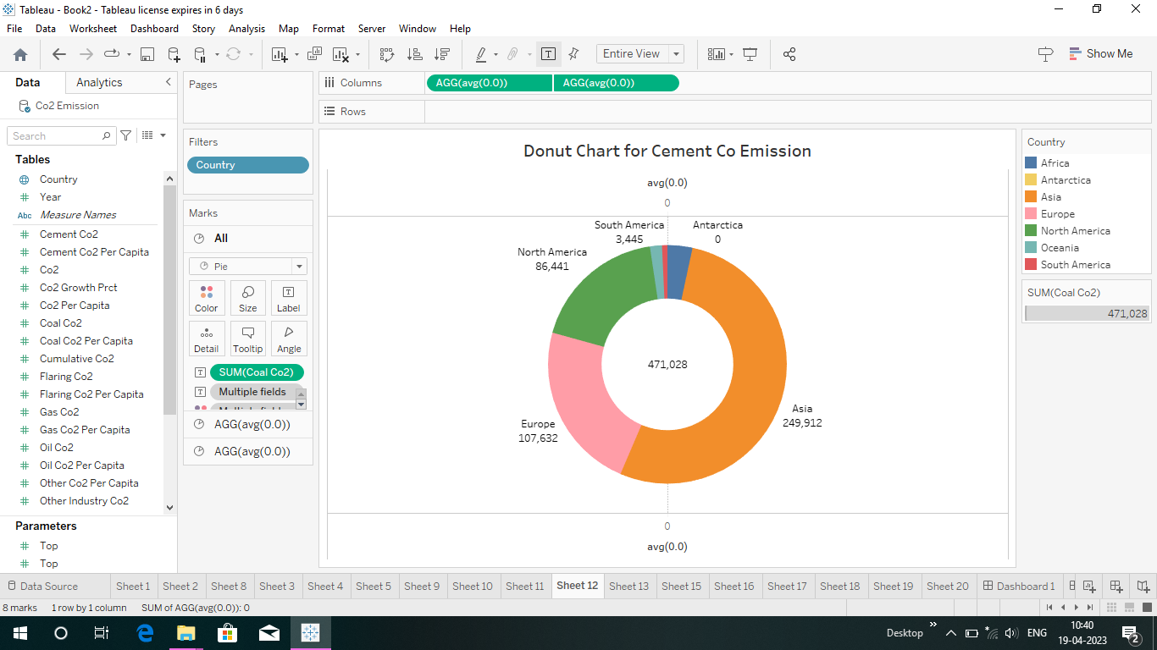

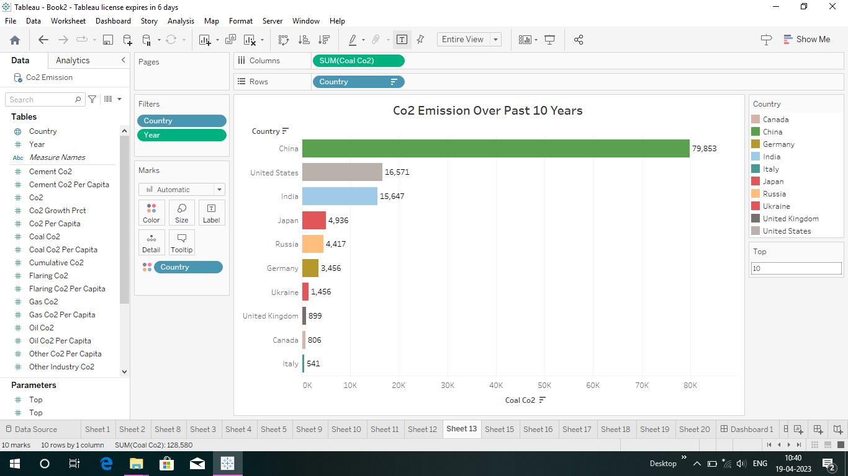

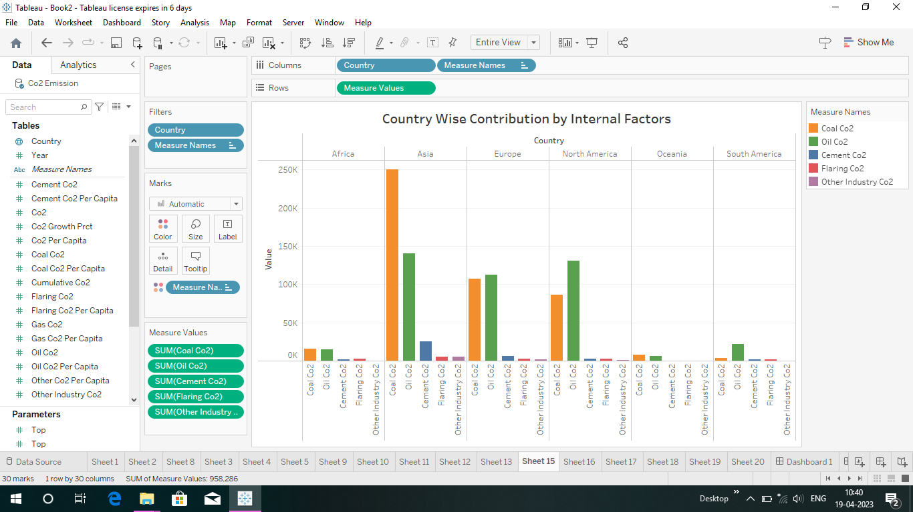

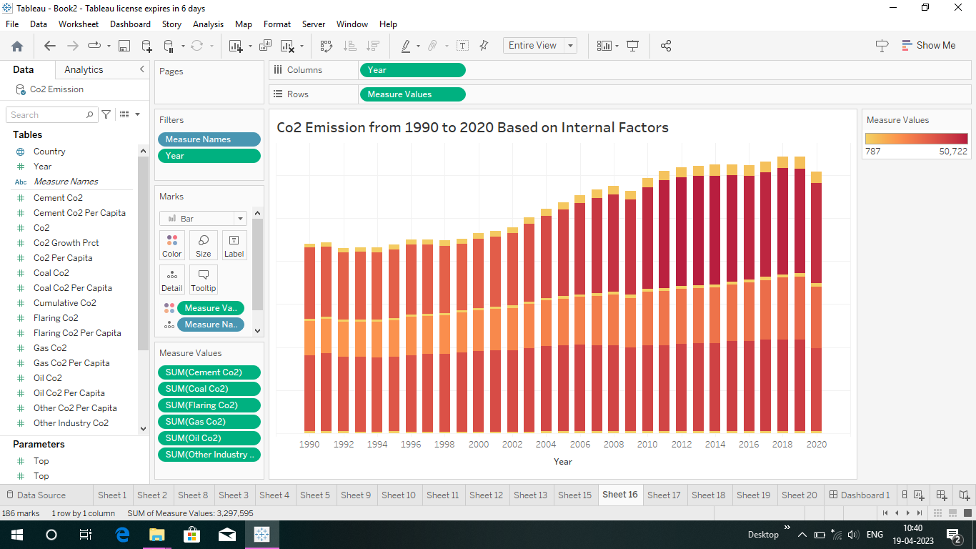

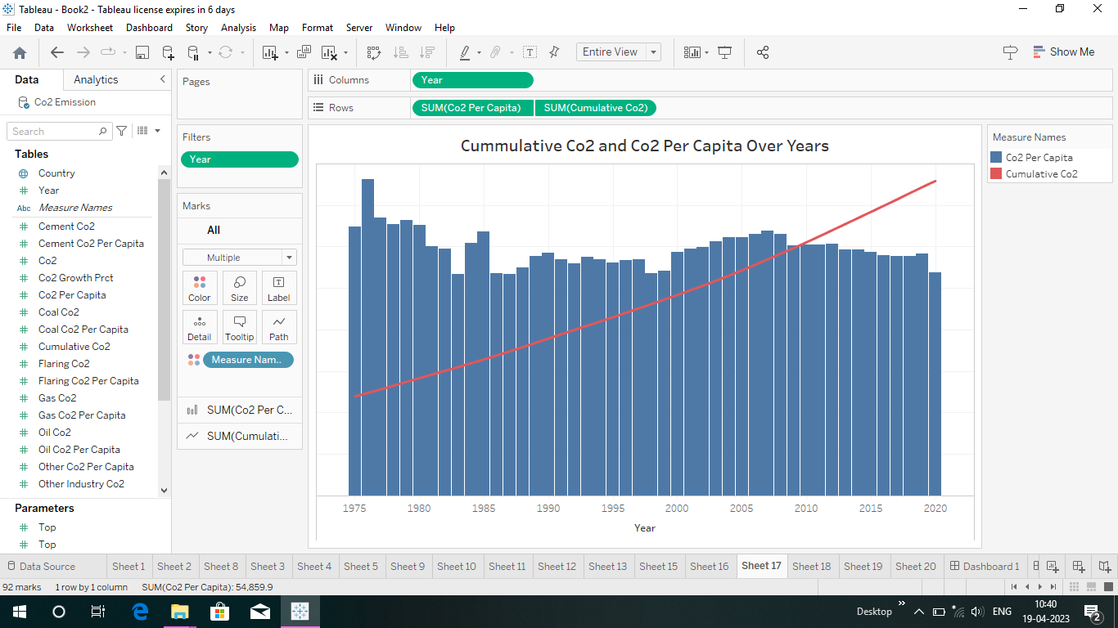  
  
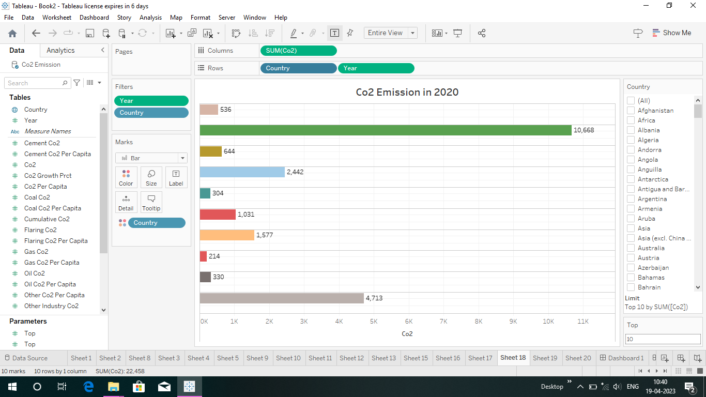

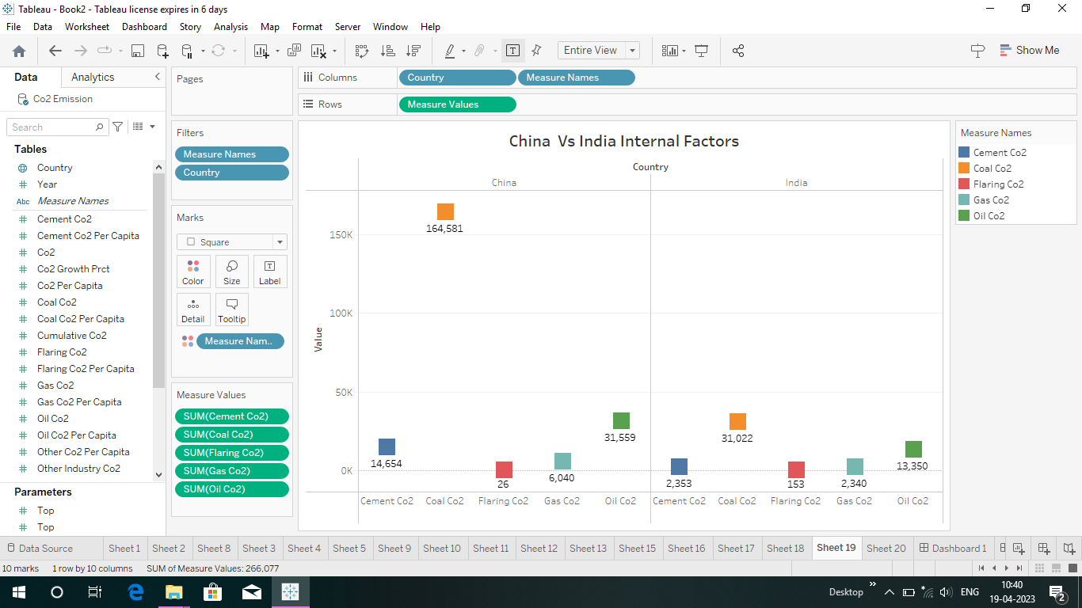

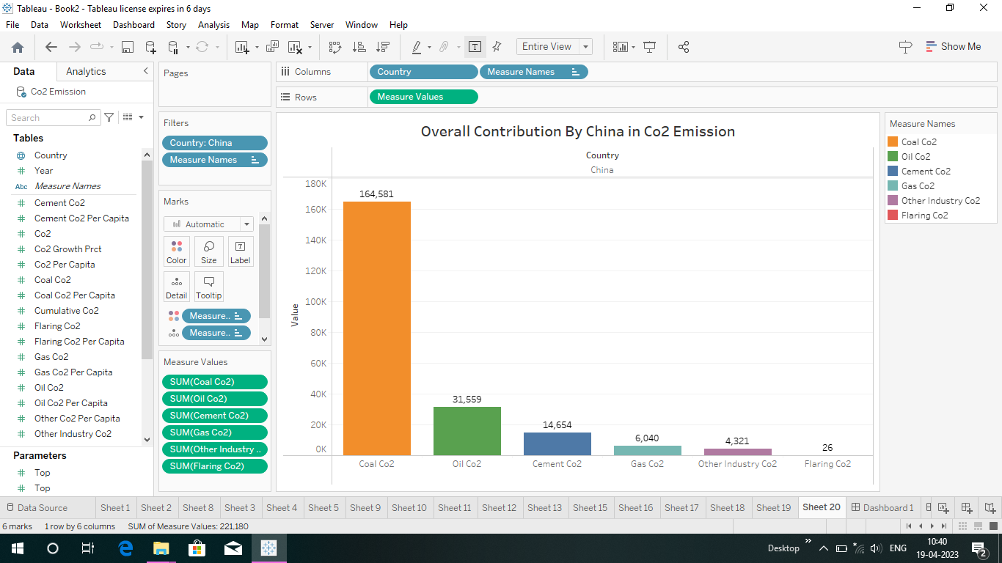

1. **Advantages and Disadvantages :-**

**Total world annual emissions**

Who emits the most CO2 each year? In the treemap visualization we show annual CO2 emissions by country, and aggregated by region. Treemaps are used to compare entities (such as countries or regions) in relation to others, and relative to the total. Here each inner rectangle represents a country – which are then nested and colored by region. The size of each rectangle corresponds to its annual CO2 emissions in 2017. Combined, all rectangles represent the global total.

The emissions shown here relate to the country where CO2 is produced (i.e.production-based CO2) , not to where the goods and services that generate emissions are finally consumed. We look at the difference in each country’s production vs. consumption (trade-adjusted) emissions [**here**](https://ourworldindata.org/grapher/production-vs-consumption-co2-emissions).

Asia is by far the largest emitter, accounting for 53% of global emissions. As it is [home to 60%](https://ourworldindata.org/grapher/world-population-by-world-regions-post-1820?stackMode=relative) of the world’s population this means that per capita emissions in Asia are slightly lower than the world average, however.

China is, by a significant margin, Asia’s and the world’s largest emitter: it emits nearly 10 billion tonnes each year, more than one-quarter of global emissions.

North America – dominated by the USA – is the second largest regional emitter at 18% of global emissions. It’s followed closely by Europe with 17%. Here we have grouped the 28 countries of the European Union together, since they typically negotiate and [set targets](https://climateactiontracker.org/countries/eu/) as a collective body. You can see the data for individual EU countries in the interactive maps which follow.

Africa and South America are both fairly small emitters: accounting for 3-4% of global emissions each. Both have emissions almost equal in size to international aviation and shipping. Both aviation and shipping are not included in national or regional emissions. This is because of disagreement over how emissions which cross country borders should be allocated: do they belong to the country of departure, or country of origin? How are connecting flights accounted for? The tensions in reaching international aviation and shipping deals are discussed in detail at the Carbon Brief [**here**](https://www.carbonbrief.org/in-depth-will-countries-finally-agree-climate-deal-for-shipping).

**3.2 Total emissions by country :**

This interactive chart shows the breakdown of global CO2 emissions by region.

We see that until well into the 20th century, global emissions were dominated by Europe and the United States.

In 1900, more than 90% of emissions were produced in Europe or the US; even by 1950, they accounted for more than 85% of emissions each year. But in recent decades this has changed significantly. In the second half of the 20th century we see a significant rise in emissions in the rest of the world, particularly across Asia, and most notably, China. The US and Europe now account for just under one-third of emissions.

**3.3 CO2 emission India vs united states:**

## India

India is the third-largest CO2 emitter, with 2,442 million metric tons of total [carbon dioxide](https://www.investopedia.com/terms/c/carbontrade.asp) emissions produced in 2020. Coal is the main energy source for India, supplying about 45% of the energy in the country. Petroleum and other liquids provided about 26%.213

Natural gas accounts for only 6% of India's energy consumption; however, the country plans to increase the natural gas market share to 15% by 2030 in order to reduce air pollution and use cleaner-burning fuels.

## U.S.

The U.S. is the second-largest emitter of CO2, with 4,713 million metric tons of total carbon dioxide emissions in 2020.2 The largest sources of CO2emissions in the U.S. came from transportation, power generation, and industry in 2020. Even though the U.S. government undertook significant efforts to [reduce](https://www.investopedia.com/terms/e/erpa.asp) the reliance on coal for electricity generation, the country has become a major producer of crude oil.

Also, the U.S. economy is heavily reliant on the transportation sector, which burns petroleum for trucks, ships, trains, and planes. U.S. consumers especially depend on their cars as their primary means of transportation, and this also contributes to the CO2 footprint through gasoline and diesel.

Another large contributor to CO2emissions in the U.S. is industry, which burns fossil fuels for energy. Also, the U.S. chemical sector uses various chemical reactions necessary to produce goods from [raw materials](https://www.investopedia.com/terms/r/rawmaterials.asp), which in the process, emit CO2.

**3.4 Total CO2 emission over time :**

How have global emissions of carbon dioxide (CO2) changed over time?

In this chart we see the growth of global emissions from the mid-18th century through to today.

We see that prior to the Industrial Revolution, emissions were very low. Growth in emissions was still relatively slow until the mid-20th century. In 1950 the world emitted 6 billion tonnes of co2.By 1990 this had almost quadrupled, reaching more than 22 billion tonnes. Emissions have continued to grow rapidly, we now emit over 34 billion tonnes each year. Emissions growth has slowed over the last few years, but they have yet to reach their peak.

**3.5 CO2  emission per capita**

This interactive chart shows the year-on-year growth rate of CO2 emissions.

A positive figure in a given year indicates that emissions were *higher* than the previous year. A negative figure indicates they were *lower* than the year before. For example, a change of 1.5% indicates that global emissions were 1.5% higher than the previous year [–1.5% would mean they were 1.5% lower].

This measure allows us to see firstly where emissions are rising, and where they are falling; and secondly the rate at which emissions are changing – whether the growth in emissions are slowing down or accelerating.

**4. Conclusion**

**6.1 Dashboard :-**

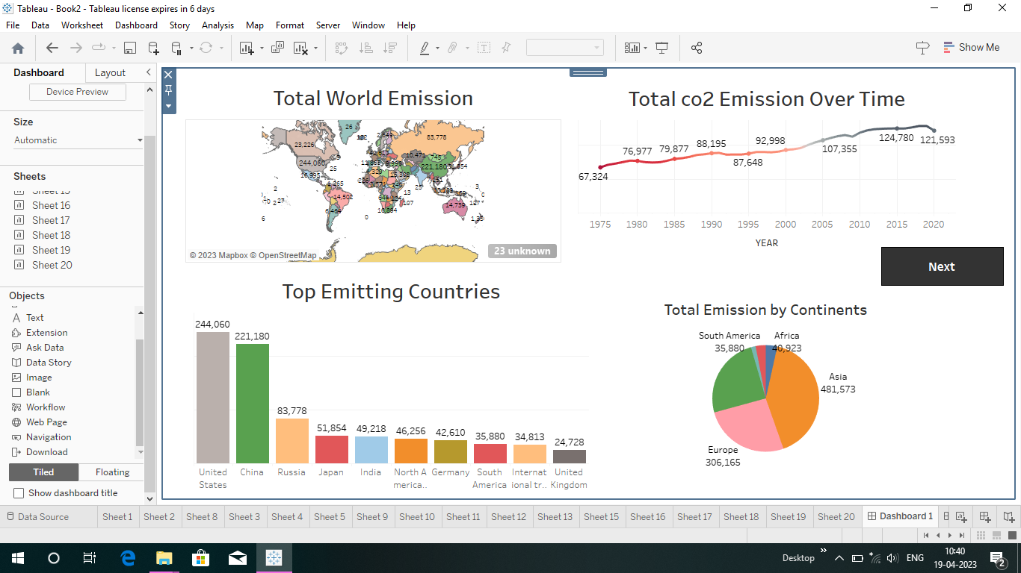

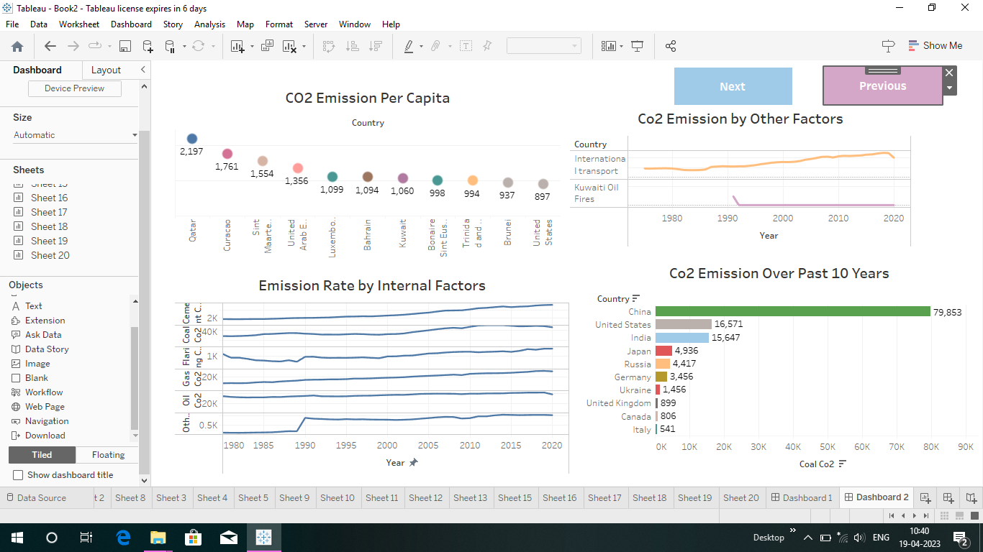

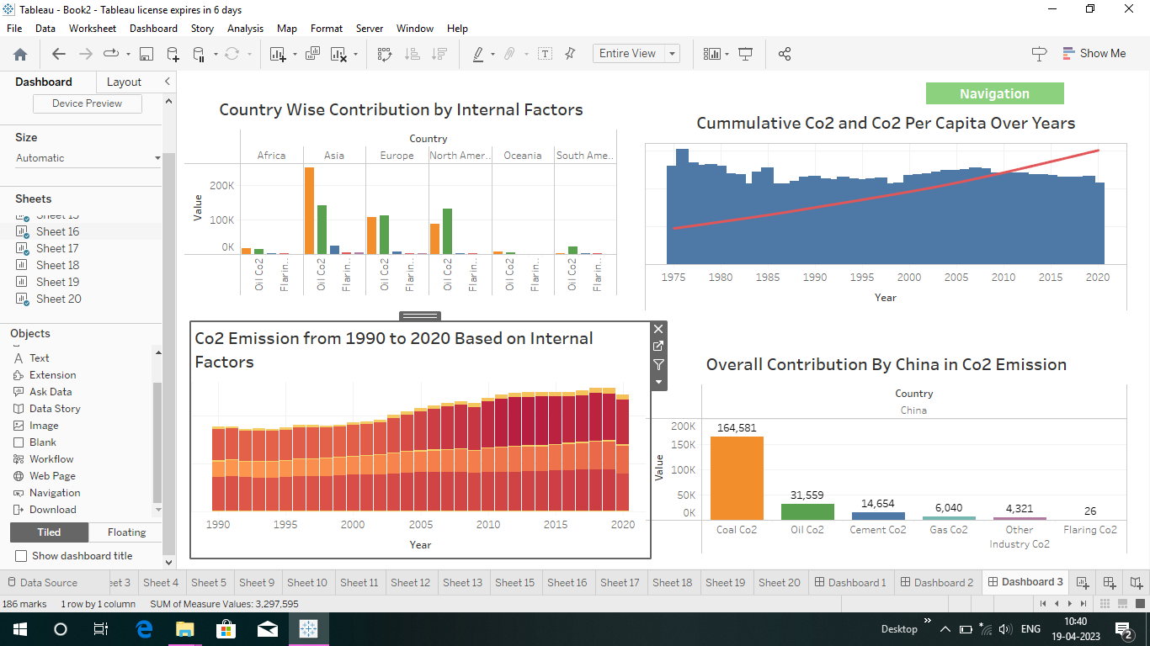

**6.2 Story :-**

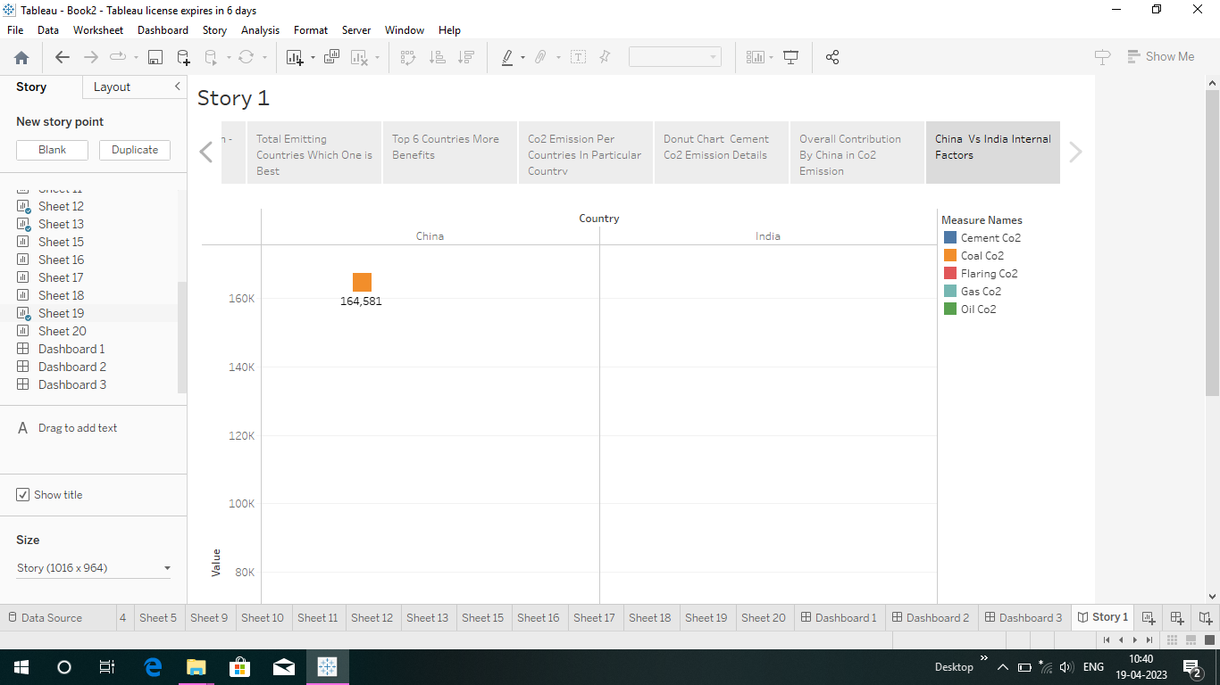

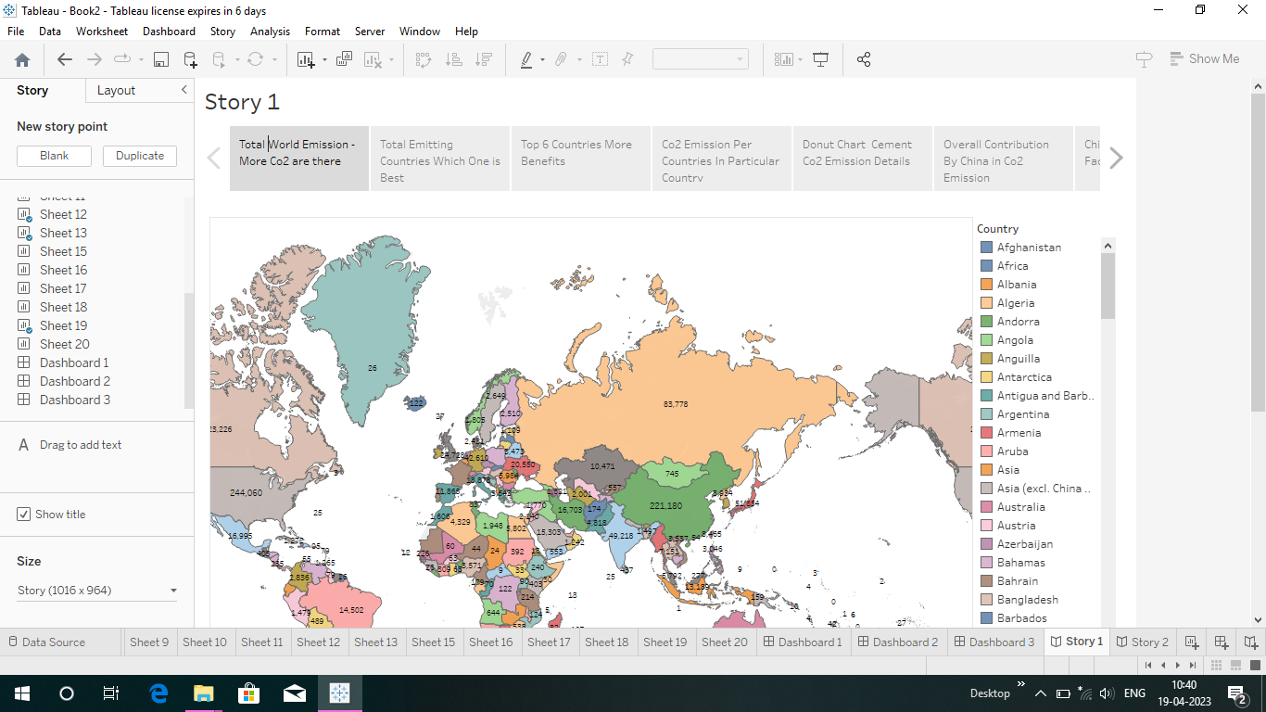

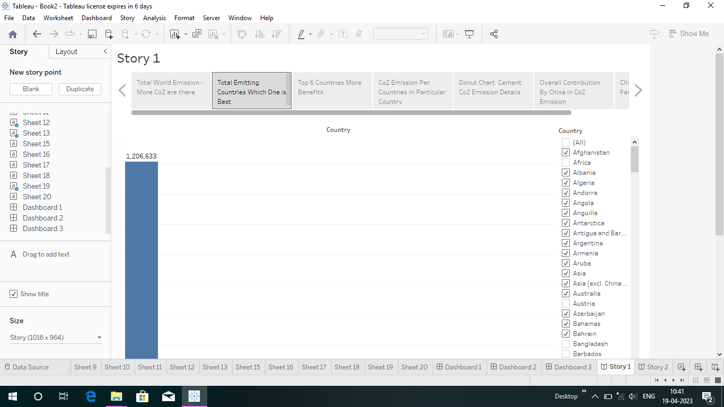

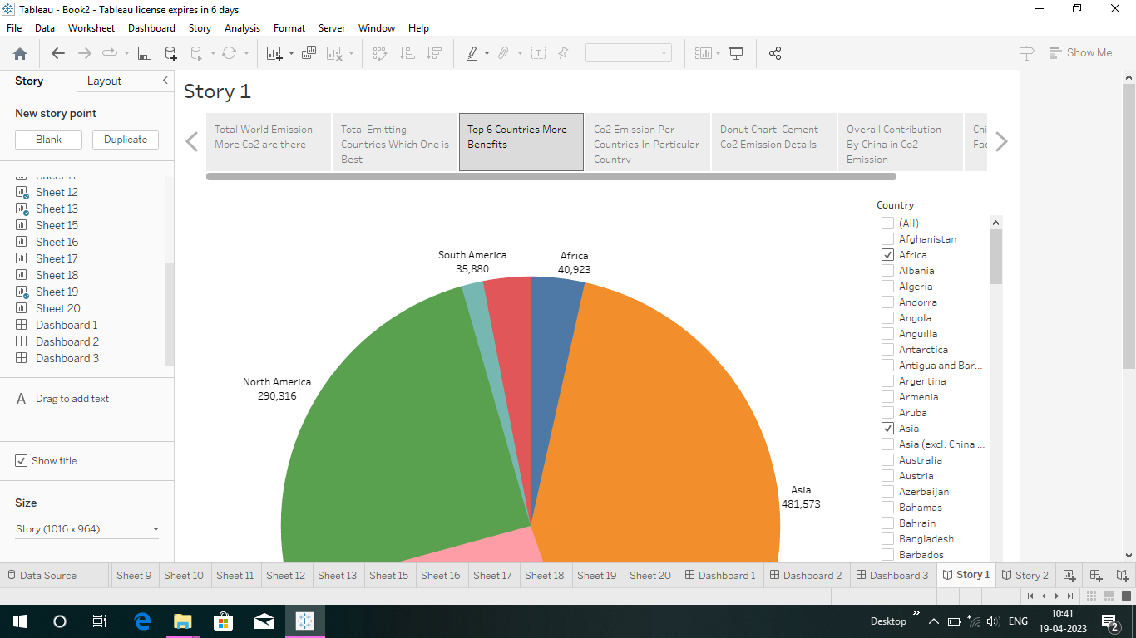

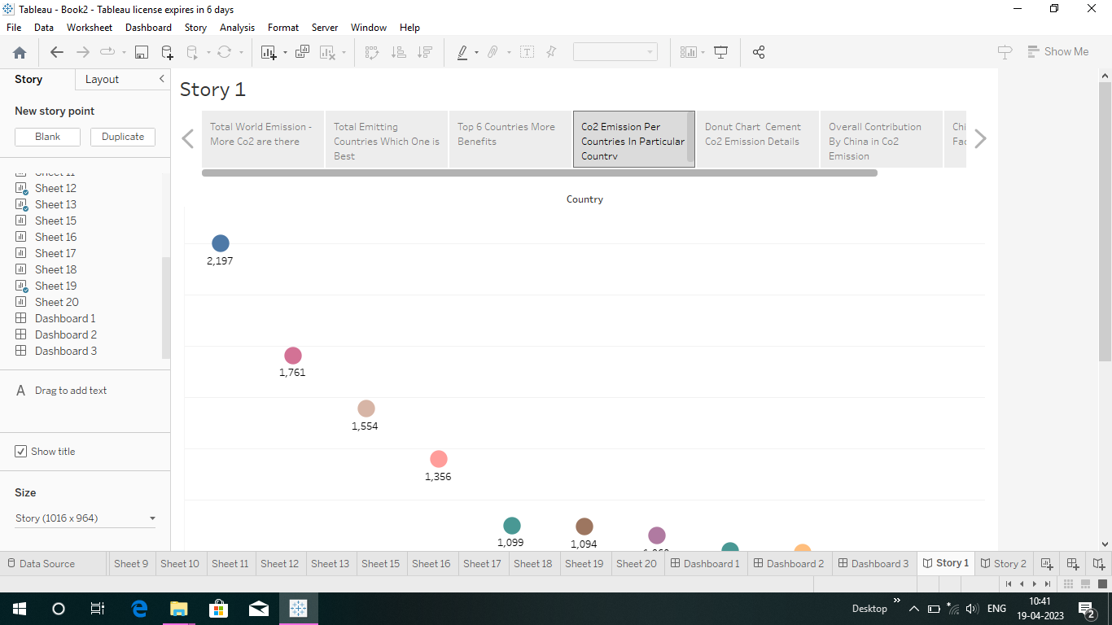

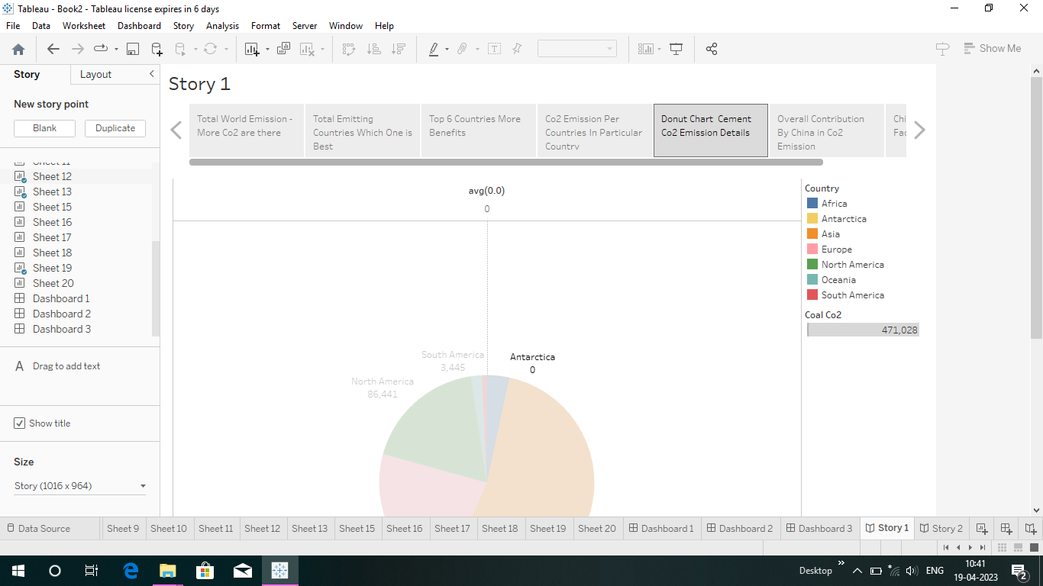

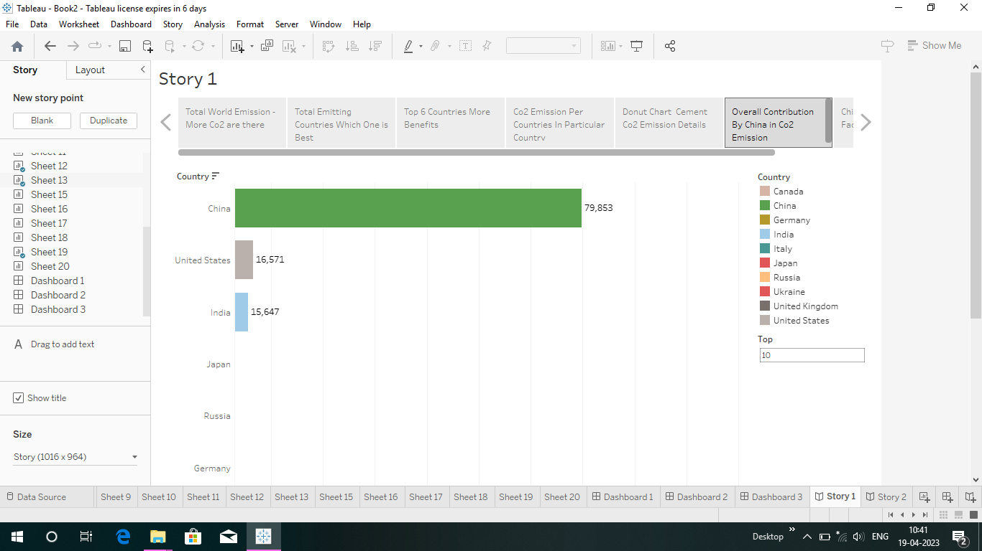

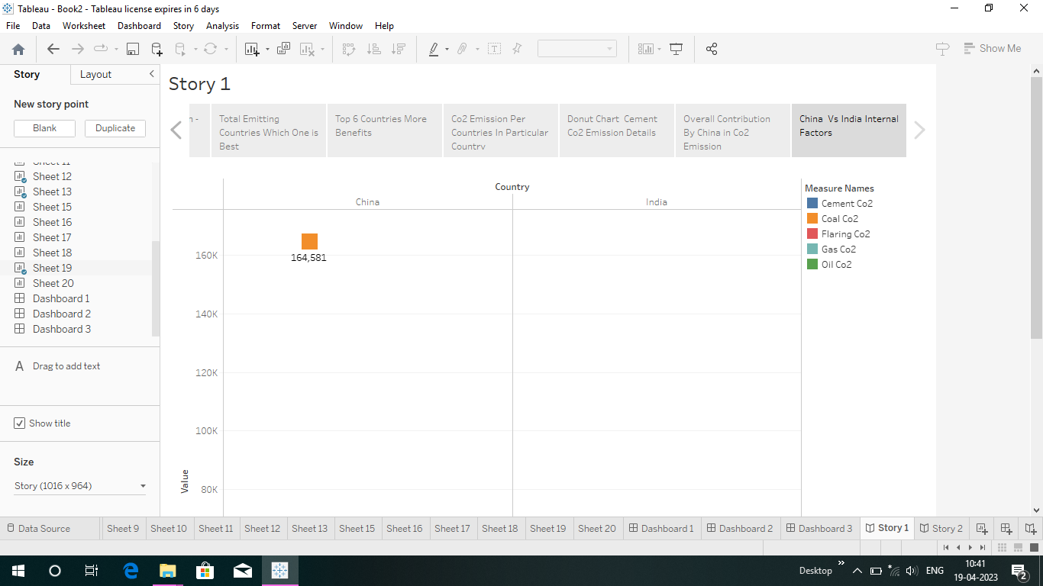

1. **Appendix :-**
2. **Source Code :-**

**<!DOCTYPE html>**

**<html lang="en">**

**<head>**

**<meta charset="utf-8">**

**<meta content="width=device-width, initial-scale=1.0" name="viewport">**

**<title>Global Co2 Emission Analysis</title>**

**<meta content="" name="description">**

**<meta content="" name="keywords">**

**<!-- Favicons -->**

**<link href="assets/img/favicon.png" rel="icon">**

**<link href="assets/img/apple-touch-icon.png" rel="apple-touch-icon">**

**<!-- Google Fonts -->**

**<link href="https://fonts.googleapis.com/css?family=Open+Sans:300,300i,400,400i,600,600i,700,700i|Jost:300,300i,400,400i,500,500i,600,600i,700,700i|Poppins:300,300i,400,400i,500,500i,600,600i,700,700i" rel="stylesheet">**

**<!-- Vendor CSS Files -->**

**<link href="assets/vendor/aos/aos.css" rel="stylesheet">**

**<link href="assets/vendor/bootstrap/css/bootstrap.min.css" rel="stylesheet">**

**<link href="assets/vendor/bootstrap-icons/bootstrap-icons.css" rel="stylesheet">**

**<link href="assets/vendor/boxicons/css/boxicons.min.css" rel="stylesheet">**

**<link href="assets/vendor/glightbox/css/glightbox.min.css" rel="stylesheet">**

**<link href="assets/vendor/remixicon/remixicon.css" rel="stylesheet">**

**<link href="assets/vendor/swiper/swiper-bundle.min.css" rel="stylesheet">**

**<!-- Template Main CSS File -->**

**<link href="assets/css/style.css" rel="stylesheet">**

**<!-- =======================================================**

**\* Template Name: Arsha - v4.10.0**

**\* Template URL: https://bootstrapmade.com/arsha-free-bootstrap-html-template-corporate/**

**\* Author: BootstrapMade.com**

**\* License: https://bootstrapmade.com/license/**

**======================================================== -->**

**</head>**

**<body>**

**<!-- ======= Header ======= -->**

**<header id="header" class="fixed-top ">**

**<div class="container d-flex align-items-center justify-content-between">**

**<h1 class="logo"><img src="https://media.istockphoto.com/id/1323550608/vector/co2-reduction-cloud-eco-vector-icon.jpg?s=612x612&w=0&k=20&c=jO3OZfYAg9gB8TWvzH8BR64Lq3pFrfHcOvxpSgB-cjA="> </h1>**

**<!-- Uncomment below if you prefer to use an image logo -->**

**<!-- <a href="index.html" class="logo me-auto"><img src="assets/img/logo.png" alt="" class="img-fluid"></a>-->**

**<nav id="navbar" class="navbar">**

**<ul>**

**<li><a class="nav-link scrollto active" href="#hero">Home</a></li>**

**<li><a class="nav-link scrollto" href="#about">About</a></li>**

**<li><a class="nav-link scrollto" href="#dash">Dashboard</a></li>**

**<li><a class="nav-link scrollto" href="#services">Story</a></li>**

**<li><a class="nav-link scrollto" href="#portfolio">Visualizations</a></li>**

**<li><a class="nav-link scrollto" href="#report">Report</a></li>**

**<li><a class="nav-link scrollto" href="#contact">Contact</a></li>**

**</ul>**

**<i class="bi bi-list mobile-nav-toggle"></i>**

**</nav>**

**<!-- .navbar -->**

**</div>**

**</header>**

**<!-- End Header -->**

**<!-- ======= Hero Section ======= -->**

**<section id="hero" class="d-flex align-items-center">**

**<div class="container">**

**<div class="row">**

**<div class="col-lg-6 d-flex flex-column justify-content-center pt-4 pt-lg-0 order-2 order-lg-1" data-aos="fade-up" data-aos-delay="200">**

**<h1>Welcome to Global Co2 Emission Analysis for Year 2020</h1>**

**<h2>Carbon dioxide emissions are the primary driver of global climate change. It’s widely recognised that to avoid the worst impacts of climate change, the world needs to urgently reduce emissions.</h2>**

**<div class="d-flex justify-content-center justify-content-lg-start">**

**<a href="#about" class="btn-get-started scrollto">Get Started</a>**

**<a href="https://www.youtube.com/watch?v=jDDaplaOz7Q" class="glightbox btn-watch-video"></a>**

**</div>**

**</div>**

**<div class="col-lg-6 order-1 order-lg-2 hero-img" data-aos="zoom-in" data-aos-delay="200">**

**<img src="https://www.treehugger.com/thmb/LbdMV9gbfA1S7Y3SB0XhlSl4EFw=/1500x0/filters:no_upscale():max_bytes(150000):strip_icc()/co-why-is-carbon-dioxide-bad-4864246_V2-4ea7c0936b5a4cd3b8d4f2b41ec02f63.png" class="img-fluid animated" alt="">**

**</div>**

**</div>**

**</div>**

**</section>**

**<!-- End Hero -->**

**<main id="main">**

**<!-- ======= Clients Section ======= -->**

**<!-- End Cliens Section -->**

**<!-- ======= About Us Section ======= -->**

**<section id="about" class="about">**

**<div class="container">**

**<div class="section-title">**

**<h2>About Us</h2>**

**</div>**

**<div class="row content">**

**<div class="col-lg-12">**

**<p>**

**Carbon dioxide emissions are those stemming from the burning of fossil fuels and the manufacture of cement. They include carbon dioxide produced during consumption of solid, liquid, and gas fuels and gas flaring.**

**</p>**

**<p>**

**Global carbon dioxide (CO2) emissions from fossil fuels and industry have increased considerably since 2000, and in 2019 reached a record high of 36.7 billion metric tons of CO2. In 2020, the COVID-19 pandemic caused global CO2 emissions to plummet five**

**percent to 34.81 billion metric tons.</p>**

**<p> Historically, major global events cause emission reductions. The 2009 global recession caused worldwide CO2 emissions to fall by approximately 460 million metric tons. But this pales in comparison to the emission reductions in**

**2020. Countries around the world were put under strict lockdowns, meaning transportation and industrial activities were significantly reduced. CO2 emission levels in India dropped for the first time in four decades in the year**

**ending March 2020. Global CO2 emissions per capita also experienced a substantial decline in 2020, falling to an average of 4.47 metric tons per person.</p>**

**</div>**

**</div>**

**</div>**

**</section>**

**<!-- End About Us Section -->**

**<!-- ======= Why Us Section ======= -->**

**<section id="dash" class="">**

**<div class="container-fluid" data-aos="fade-up">**

**<div class="section-title">**

**<h2>Dashboard</h2>**

**</div>**

**<div class='tableauPlaceholder' id='viz1672205035633' style='position: relative'><noscript><a href='#'><img alt='Dashboard 1 ' src='https:&#47;&#47;public.tableau.com&#47;static&#47;images&#47;Co&#47;Co2dash&#47;Dashboard1&#47;1_rss.png' style='border: none' /></a></noscript><object class='tableauViz' style='display:none;'><param name='host_url' value='https%3A%2F%2Fpublic.tableau.com%2F' /> <param name='embed_code_version' value='3' /> <param name='site_root' value='' /><param name='name' value='Co2dash&#47;Dashboard1' />**

**<param name='tabs' value='no' /><param name='toolbar' value='yes' />**

**<param name='static_image' value='https:&#47;&#47;public.tableau.com&#47;static&#47;images&#47;Co&#47;Co2dash&#47;Dashboard1&#47;1.png' />**

**<param name='animate_transition' value='yes' />**

**<param name='display_static_image' value='yes' />**

**<param name='toolbar' value='no' />**

**<param name='display_spinner' value='yes' />**

**<param name='display_overlay' value='yes' />**

**<param name='display_count' value='yes' />**

**<param name='language' value='en-US' />**

**<param name='showShareOptions' value='false' />**

**</object>**

**</div>**

**<script type='text/javascript'>**

**var divElement = document.getElementById('viz1672205035633');**

**var vizElement = divElement.getElementsByTagName('object')[0];**

**if (divElement.offsetWidth > 800) {**

**vizElement.style.width = '100%';**

**vizElement.style.height = (divElement.offsetWidth * 0.75) + 'px';**

**} else if (divElement.offsetWidth > 500) {**

**vizElement.style.width = '90%';**

**vizElement.style.height = (divElement.offsetWidth * 0.75) + 'px';**

**} else {**

**vizElement.style.width = '100%';**

**vizElement.style.height = '1477px';**

**}**

**var scriptElement = document.createElement('script');**

**scriptElement.src = 'https://public.tableau.com/javascripts/api/viz_v1.js';**

**vizElement.parentNode.insertBefore(scriptElement, vizElement);**

**</script>**

**</div>**

**<!-- End Why Us Section -->**

**<section id="services" class="services">**

**<div class="container" data-aos="fade-up">**

**<div class="section-title">**

**<h2>Story</h2>**

**</div>**

**<div class='tableauPlaceholder' id='viz1672206123585' style='position: relative'>**

**<noscript><a href='#'><img alt='CO2 Emission Story ' src='https:&#47;&#47;public.tableau.com&#47;static&#47;images&#47;G4&#47;G4Q8N94F4&#47;1_rss.png' style='border: none' /></a>**

**</noscript><object class='tableauViz' style='display:none;'>**

**<param name='host_url' value='https%3A%2F%2Fpublic.tableau.com%2F' />**

**<param name='embed_code_version' value='3' /> <param name='path' value='shared&#47;G4Q8N94F4' />**

**<param name='toolbar' value='yes' />**

**<param name='static_image' value='https:&#47;&#47;public.tableau.com&#47;static&#47;images&#47;G4&#47;G4Q8N94F4&#47;1.png' />**

**<param name='animate_transition' value='yes' />**

**<param name='display_static_image' value='yes' />**

**<param name='display_spinner' value='yes' />**

**<param name='display_overlay' value='yes' />**

**<param name='display_count' value='yes' />**

**<param name='language' value='en-US' /></object></div>**

**<script type='text/javascript'>**

**var divElement = document.getElementById('viz1672206123585');**

**var vizElement = divElement.getElementsByTagName('object')[0];**

**vizElement.style.width = '100%';**

**vizElement.style.height = (divElement.offsetWidth * 0.75) + 'px';**

**var scriptElement = document.createElement('script');**

**scriptElement.src = 'https://public.tableau.com/javascripts/api/viz_v1.js';**

**vizElement.parentNode.insertBefore(scriptElement, vizElement);**

**</script>**

**</div>**

**</section>**

**<!-- ======= Skills Section ======= -->**

**<!-- End Skills Section -->**

**<!-- End Services Section -->**

**<!-- ======= Cta Section ======= -->**

**<!-- End Cta Section -->**

**<!-- ======= Portfolio Section ======= -->**

**<section id="portfolio" class="portfolio">**

**<div class="container" data-aos="fade-up">**

**<div class="section-title">**

**<h2>Visualizations</h2>**

**</div>**

**<div class="row portfolio-container">**

**<div class="col-lg-4 col-md-6 portfolio-item filter-web">**

**<div class="portfolio-wrap">**

**<img src="assets/img/img2.jpg" class="img-fluid" alt="">**

**<div class="portfolio-info">**

**<h4>Image 1 </h4>**

**<div class="portfolio-links">**

**<a href="assets/img/portfolio/p1.jpg" data-gallery="portfolioGallery" class="portfolio-lightbox" title="Web 3"><i class="bx bx-plus"></i></a>**

**</div>**

**</div>**

**</div>**

**</div>**

**<div class="col-lg-4 col-md-6 portfolio-item filter-web">**

**<div class="portfolio-wrap">**

**<img src="assets/img/img3.jpg" class="img-fluid" alt="">**

**<div class="portfolio-info">**

**<h4>Image 2 </h4>**

**<div class="portfolio-links">**

**<a href="assets/img/portfolio/p1.jpg" data-gallery="portfolioGallery" class="portfolio-lightbox" title="Web 3"><i class="bx bx-plus"></i></a>**

**</div>**

**</div>**

**</div>**

**</div>**

**<div class="col-lg-4 col-md-6 portfolio-item filter-web">**

**<div class="portfolio-wrap">**

**<img src="assets/img/img4.jpg" class="img-fluid" alt="">**

**<div class="portfolio-info">**

**<h4>Image 3 </h4>**

**<div class="portfolio-links">**

**<a href="assets/img/portfolio/p1.jpg" data-gallery="portfolioGallery" class="portfolio-lightbox" title="Web 3"><i class="bx bx-plus"></i></a>**

**</div>**

**</div>**

**</div>**

**</div>**

**<div class="col-lg-4 col-md-6 portfolio-item filter-web">**

**<div class="portfolio-wrap">**

**<img src="assets/img/img5.jpg" class="img-fluid" alt="">**

**<div class="portfolio-info">**

**<h4>Image 5</h4>**

**<div class="portfolio-links">**

**<a href="assets/img/portfolio/p5.jpg" data-gallery="portfolioGallery" class="portfolio-lightbox" title="Web 3"><i class="bx bx-plus"></i></a>**

**</div>**

**</div>**

**</div>**

**</div>**

**<div class="col-lg-4 col-md-6 portfolio-item filter-web">**

**<div class="portfolio-wrap">**

**<img src="assets/img/img6.jpg" class="img-fluid" alt="">**

**<div class="portfolio-info">**

**<h4>Image 6</h4>**

**<div class="portfolio-links">**

**<a href="assets/img/portfolio/p5.jpg" data-gallery="portfolioGallery" class="portfolio-lightbox" title="Web 3"><i class="bx bx-plus"></i></a>**

**</div>**

**</div>**

**</div>**

**</div>**

**<div class="col-lg-4 col-md-6 portfolio-item filter-web">**

**<div class="portfolio-wrap">**

**<img src="assets/img/img7.jpg" class="img-fluid" alt="">**

**<div class="portfolio-info">**

**<h4>Image 4</h4>**

**<div class="portfolio-links">**

**<a href="assets/img/portfolio/p5.jpg" data-gallery="portfolioGallery" class="portfolio-lightbox" title="Web 3"><i class="bx bx-plus"></i></a>**

**</div>**

**</div>**

**</div>**

**</div>**

**</div>**

**</div>**

**</section>**

**<section id="report" class="skills">**

**<div class="container" data-aos="fade-up">**

**<div class="section-title">**

**<h2>Report</h2>**

**</div>**

**<div class="row content">**

**<div class="col-md-5 order-1 order-md-2" data-aos="fade-right" data-aos-delay="100">**

**<img src="assets/img/r1.jpg" class="img-fluid" alt="">**

**</div>**

**<div class="col-lg-6 pt-4 pt-lg-0 content" data-aos="fade-left" data-aos-delay="100">**

**<h3>Top Co2 Emitting countries for Past 10 Years</h3>**

**<br>**

**<p class="fst-italic">**

**China is the highest Co2 Emitting country among the other countries.**

**</p>**

**<p class="fst-italic">**

**United States is the second highest Co2 Emitting country.**

**</p>**

**<p class="fst-italic">**

**India is the Third highest Co2 Emitting country.**

**</p>**

**</div>**

**</div>**

**<br>**

**<br>**

**<div class="row content">**

**<div class="col-md-5" data-aos="fade-right">**

**<img src="assets/img/r2.jpg" class="img-fluid" alt="">**

**</div>**

**<div class="col-md-7 pt-5" data-aos="fade-left">**

**<h3>Continents Contribution towards Co2 Emission</h3>**

**<br>**

**<p class="fst-italic">**

**Asian is the highest Co2 Emitting country among the other continents.**

**</p>**

**<p class="fst-italic">**

**Europe is the second highest Co2 Emitting continent.**

**</p>**

**<p class="fst-italic">**

**Antartica is the lowest Co2 Emitting countries because of low human activity/existence in the continent.**

**</p>**

**</div>**

**<br>**

**<br>**

**<div class="row content">**

**<div class="col-md-5" data-aos="fade-right">**

**<img src="assets/img/r3.jpg" class="img-fluid" alt="">**

**</div>**

**<div class="col-md-7 pt-5" data-aos="fade-left">**

**<h3>Overall India Contribution towards Co2 Emission</h3>**

**<br>**

**<p class="fst-italic">**

**Coal is the highest factor of Co2 Emission.**

**</p>**

**<p class="fst-italic">**

**Oil is the second highest Co2 Emitting factor.**

**</p>**

**</div>**

**</div>**

**<div class="row content">**

**<div class="col-md-5 order-1 order-md-2" data-aos="fade-left">**

**<img src="assets/img/r5.jpg" class="img-fluid" alt="">**

**</div>**

**<div class="col-md-7 pt-5 order-2 order-md-1" data-aos="fade-right">**

**<h3>Overall Co2 Emission over time </h3>**

**<br>**

**<p class="fst-italic">**

**Co2 Emission in 1975 was 67324 (in metric tons).**

**</p>**

**<p class="fst-italic">**

**Co2 Emission in 2019 was 128423 (in metric tons) which was highest in the past years.**

**</p>**

**<p class="fst-italic">**

**Co2 Emission in 2020 was found to be 121593 (in metric tons).**

**</p>**

**</div>**

**</div>**

**</div>**

**</div>**

**</section>**

**<!-- End Portfolio Section -->**

**<!-- ======= Team Section ======= -->**

**<!-- End Team Section -->**

**<!-- ======= Pricing Section ======= -->**

**<!-- End Pricing Section -->**

**<!-- ======= Contact Section ======= -->**

**<section id="contact" class="contact">**

**<div class="container" data-aos="fade-up">**

**<div class="section-title">**

**<h2>Contact</h2>**

**</div>**

**<div class="row">**

**<div class="col-lg-5 d-flex align-items-stretch">**

**<div class="info">**

**<div class="address">**

**<i class="bi bi-geo-alt"></i>**

**<h4>Location:</h4>**

**<p>SmartBridge, Hyderabad,AndhraPradesh, India</p>**

**</div>**

**<div class="email">**

**<i class="bi bi-envelope"></i>**

**<h4>Email:</h4>**

**<p>info@smartbridge.com<br>contact@smartbridge.com</p>**

**</div>**

**<div class="phone">**

**<i class="bi bi-phone"></i>**

**<h4>Call:</h4>**

**<p>+11 1234 1234<br>+11 4321 4321</p>**

**</div>**

**</div>**

**</div>**

**<div class="col-lg-7 mt-5 mt-lg-0 d-flex align-items-stretch">**

**<form action="forms/contact.php" method="post" role="form" class="php-email-form">**

**<div class="row">**

**<div class="form-group col-md-6">**

**<label for="name">Your Name</label>**

**<input type="text" name="name" class="form-control" id="name" required>**

**</div>**

**<div class="form-group col-md-6">**

**<label for="name">Your Email</label>**

**<input type="email" class="form-control" name="email" id="email" required>**

**</div>**

**</div>**

**<div class="form-group">**

**<label for="name">Subject</label>**

**<input type="text" class="form-control" name="subject" id="subject" required>**

**</div>**

**<div class="form-group">**

**<label for="name">Message</label>**

**<textarea class="form-control" name="message" rows="10" required></textarea>**

**</div>**

**<div class="my-3">**

**<div class="loading">Loading</div>**

**<div class="error-message"></div>**

**<div class="sent-message">Your message has been sent. Thank you!</div>**

**</div>**

**<div class="text-center"><button type="submit">Send Message</button></div>**

**</form>**

**</div>**

**</div>**

**</div>**

**</section>**

**<!-- End Contact Section -->**

**</main>**

**<!-- End #main -->**

**<!-- ======= Footer ======= -->**

**<footer id="footer">**

**<div class="footer-top">**

**<div class="container">**

**</div>**

**</div>**

**<div class="container footer-bottom clearfix">**

**<div class="copyright">**

**&copy; Copyright <strong><span>Arsha</span></strong>. All Rights Reserved**

**</div>**

**<div class="credits">**

**<!-- All the links in the footer should remain intact. -->**

**<!-- You can delete the links only if you purchased the pro version. -->**

**<!-- Licensing information: https://bootstrapmade.com/license/ -->**

**<!-- Purchase the pro version with working PHP/AJAX contact form: https://bootstrapmade.com/arsha-free-bootstrap-html-template-corporate/ -->**

**Designed by <a href="https://bootstrapmade.com/">Indra Prakash</a>**

**<div class="social-links mt-3">**

**<a href="#" class="twitter"><i class="bx bxl-twitter"></i></a>**

**<a href="#" class="facebook"><i class="bx bxl-facebook"></i></a>**

**<a href="#" class="instagram"><i class="bx bxl-instagram"></i></a>**

**<a href="#" class="google-plus"><i class="bx bxl-skype"></i></a>**

**<a href="#" class="linkedin"><i class="bx bxl-linkedin"></i></a>**

**</div>**

**</div>**

**</div>**

**</footer>**

**<!-- End Footer -->**

**<div id="preloader"></div>**

**<a href="#" class="back-to-top d-flex align-items-center justify-content-center"><i class="bi bi-arrow-up-short"></i></a>**

**<!-- Vendor JS Files -->**

**<script src="assets/vendor/aos/aos.js"></script>**

**<script src="assets/vendor/bootstrap/js/bootstrap.bundle.min.js"></script>**

**<script src="assets/vendor/glightbox/js/glightbox.min.js"></script>**

**<script src="assets/vendor/isotope-layout/isotope.pkgd.min.js"></script>**

**<script src="assets/vendor/swiper/swiper-bundle.min.js"></script>**

**<script src="assets/vendor/waypoints/noframework.waypoints.js"></script>**

**<script src="assets/vendor/php-email-form/validate.js"></script>**

**<!-- Template Main JS File -->**

**<script src="assets/js/main.js"></script>**

**</body>**

**</html>**